Page replacement Algorithm
FIFO
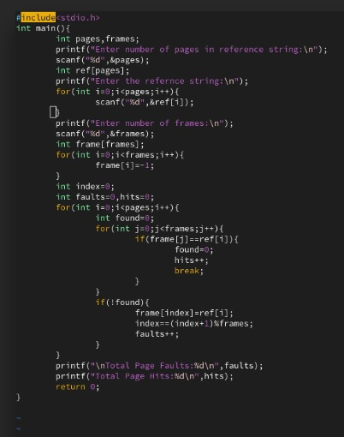
Lru
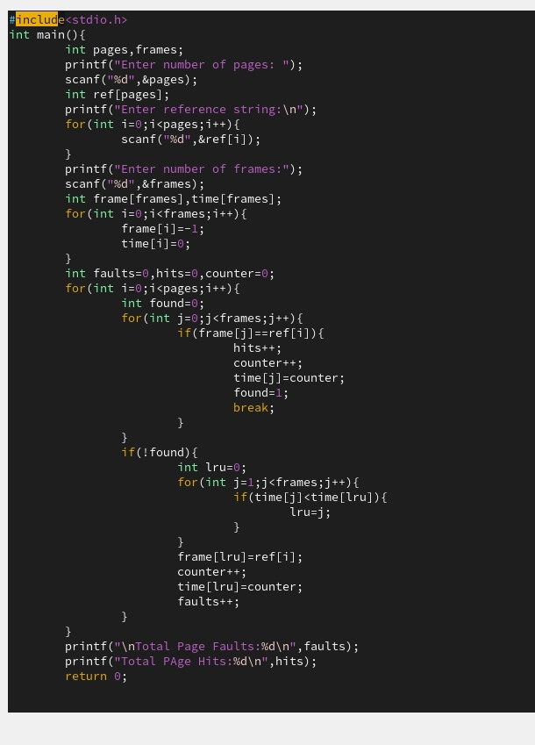
Optimal
#include <stdio.h>

int search(int key, int frame_items[], int frame_occupied)
{
for (int i = 0; i < frame_occupied; i++)
{
if (frame_items[i] == key)
return 1;
}
return 0;
}

void optimalPage(int reference_string[], int ref_len, int frames)
{
int frame_items[frames];
int page_faults = 0;
int frame_occupied = 0;

for (int i = 0; i < frames; i++)
frame_items[i] = -1;

printf("Ref String\tFrames\n");

for (int i = 0; i < ref_len; i++)
{
int current_page = reference_string[i];

if (search(current_page, frame_items, frame_occupied))
{
printf("%d\t\t", current_page);

for (int j = 0; j < frames; j++)
printf("%d ", frame_items[j]);

printf("\n");
continue;
}

page_faults++;

if (frame_occupied < frames)
{
frame_items[frame_occupied] = current_page;
frame_occupied++;
}
else
{
int farthest = -1;
int replace_index = -1;

for (int j = 0; j < frames; j++)
{
int k;

for (k = i + 1; k < ref_len; k++)
{
if (frame_items[j] == reference_string[k])
{
if (k > farthest)
{
farthest = k;
replace_index = j;
}
break;
}
}

if (k == ref_len)
{
replace_index = j;
break;
}
}

frame_items[replace_index] = current_page;
}

printf("%d\t\t", current_page);

for (int j = 0; j < frames; j++)
printf("%d ", frame_items[j]);

printf("\n");
}

printf("\nTotal Page Faults = %d\n", page_faults);
}

int main()
{
int reference_string[] = {7, 0, 1, 2, 0, 3, 0, 4, 2, 3, 0, 3, 2};
int ref_len = sizeof(reference_string) / sizeof(reference_string[0]);
int frames = 3;

optimalPage(reference_string, ref_len, frames);

return 0;
}

